Krishna Chaitanya Goteti
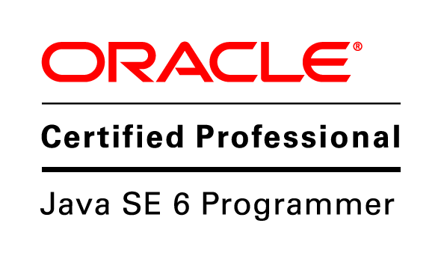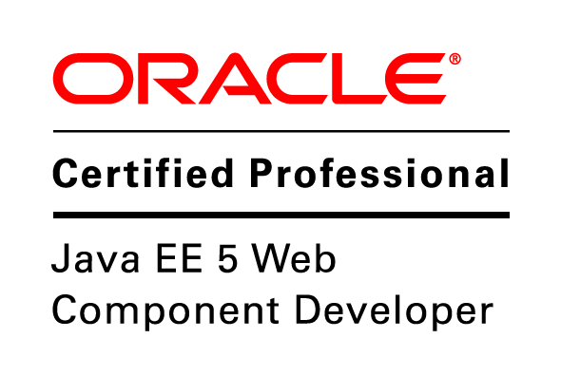
chaitu.goteti@gmail.com
+91-90081-15544

Professional Profile:
An enthusiastic and dedicated professional with 5.2 years of extensive experience on developing, managing and implementing solutions using Java and J2EE technologies with Struts framework.

Education:

- Master of Computer Applications (June 2009) from JNT University, Kakinada.

- Bachelor of Science (May 2006) from ANDHRA University.

Technical Skills:
Primary Skills : Java and J2EE, MySQL, DB2, IBM WAS, Hibernate
Operating Systems : Windows 98/XP/2000, MS-DOS, AIX, Linux
Scripting Languages : JavaScript, Shell Script
Middle Ware Tools : IBM MQ, Web Services
Frameworks : Struts, Spring

Work Experience:

- Working as Solution Integration Consultant I with Fair Isaac India Software Pvt. Ltd., Bangalore, India, April 2014 – till date.

- Worked as Senior Consultant in Allstate Solutions Pvt. Ltd., Bangalore, India, June 2013 – April 2014.

- Worked as Application Developer in IBM India Pvt. Ltd., Bangalore, India, January 2010 – June 2013.

• Worked as Software Developer in Fortuity Infotech Hyderabad since
September 09 to January 10.

Mar. 2014 – Till Date Fair Isaac India Software Pvt. Ltd., Bangalore

Application : Debt Manager
Environment : J2EE, Struts, DB2
Role : Solution Integration Consultant I.
Clients : DBS Singapore, Barclay Card UK

Jun. 2013 – Apr. 2014 Allstate Solutions Pvt. Ltd., Bangalore

Application : Specialty Products
Environment : J2EE, Struts, AS400
Role : Senior Consultant.

Dec. 2012 – Jun. 2013 IBM India Pvt. Ltd., Bangalore

Application : Enovia to MirrorMart Pull, PDIH, SQMS II, ERE, ROHS
QPEX
Environment : Java/J2EE, WAS, Struts, MQ, DB2
Role : Application Developer.

Professional Responsibilities:

- Performing requirements analysis, design, development, unit testing, deployment.
- Preparing ROM estimates for the requirements.
- Working with on-site, testing and deployment teams in getting applications ready and deployed on time.
- Analyzing root cause for the issues reported in production and addressing them on time with good quality.
- Coordinating with different teams to get deployment done in different environments.
- Testing the applications such that they are in compliant with IBM WWW and W3 standards and fixing the issues reported through the RPT tool.
- Preparing the application and sending for WSCR analysis review and fixing the issues reported in WSCR
- Preparing the application and sending for DQA review and fixing the issues reported in DQA
- Preparing the application and sending it for WASC and fixing the issues reported in WASC
- Preparing the ear files and intimating different teams to get them deployed and assisting deployment teams in proper configuration for the proper functioning of application.

